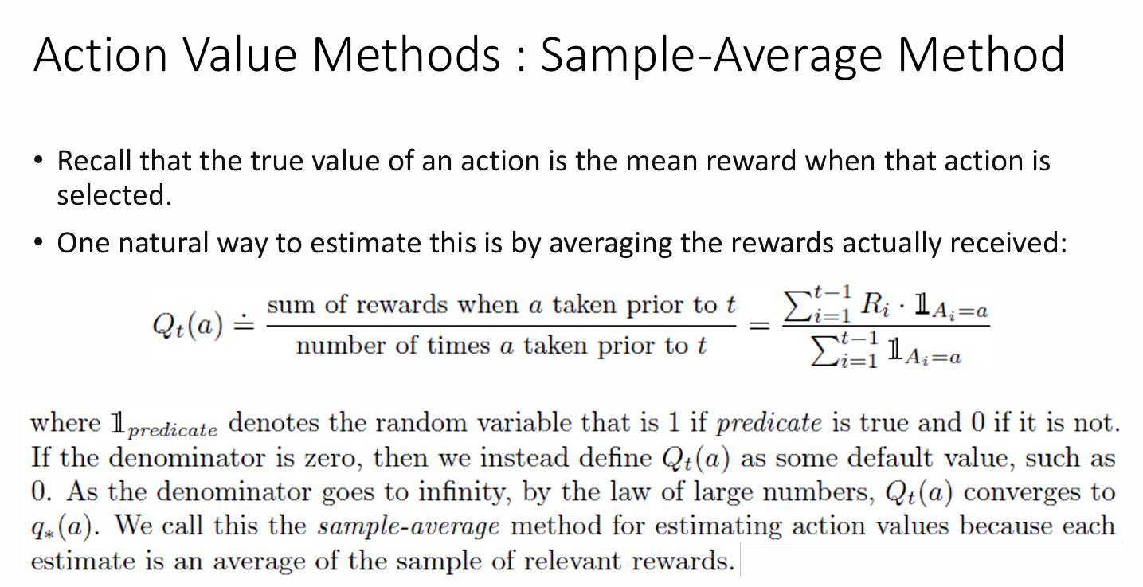

The image you sent depicts the concept of sample-average method, a technique used in reinforcement learning to estimate the value of an action.

The text within the image explains that the true value of an action signifies the average reward received whenever that particular action is chosen. The sample-average method approximates this value by averaging the rewards that have actually been obtained through trial and error.

Here’s a mathematical representation of the concept given in the image:

* **Qt(a)** represents the estimated value of action ‘a’ at time step ‘t’.
* **Σ R(i) | A(i) = a - 1** signifies the sum of rewards received up to time step ‘t-1’ where action ‘a’ was taken.
* **Σ 1(A(i) = a)** represents the total number of times action ‘a’ was taken up to time step ‘t-1’.

The summation sign (Σ) signifies that we’re calculating the total reward or the number of times an action was taken across all instances where the specific action ‘a’ was chosen. The notation 1(A(i) = a) is called an indicator function. It assigns a value of 1 if the condition A(i) = a is true and assigns a value of 0 otherwise.

In essence, this formula calculates the average reward obtained by taking action ‘a’ across all the instances where it has been chosen so far. As the agent interacts with the environment and gathers more experience, the value of t keeps increasing, and the estimate Qt(a) gets refined to more accurately reflect the true value of the action.

The text also mentions that if the number of times a particular action has been chosen (Σ 1(A(i) = a)) is zero, then the estimated value Qt(a) is assigned a default value, typically 0. This is because we cannot calculate an average if there isn't any data.

By the Law of Large Numbers, as the number of times an action is taken approaches infinity, the estimated value Qt(a) gets closer and closer to the true value, q(a). This is why it’s called the sample-average method – it approximates the value of an action by averaging the collected samples of rewards received through trial and error.

he notation 1(A(i) = a) you're referring to is indeed called an **indicator function**. It's a mathematical tool used extensively in various fields, including reinforcement learning. Here's a breakdown of what it means:

* **Function:** It's a rule that takes one input (in this case, a condition) and produces a single output based on that condition.
* **Indicator:** It acts like a signal, indicating whether a specific condition is true or false.
* **Notation:**
  + 1(A(i) = a): This is a common way to represent an indicator function. Here, 1 signifies "true" and 0 signifies "false."
  + A(i) = a: This is the condition being evaluated. A(i) represents some statement or event at a particular time step 'i' (i could represent any instance). In this specific case, we're checking if A(i) is equal to a (where a is a constant value).

**How it works:**

Imagine you have a light bulb. The indicator function acts like a switch:

* If the condition A(i) = a is true (think of the light bulb being on), the function outputs 1 (like the switch being in the "on" position).
* If the condition A(i) = a is false (think of the light bulb being off), the function outputs 0 (like the switch being in the "off" position).

**Example in Reinforcement Learning:**

In reinforcement learning, the indicator function is often used to calculate the number of times a specific action was taken. Here's an example:

* Let's say A(i) represents the action taken at time step 'i'.
* We want to find out how many times an agent took action 'a' throughout its learning process.

We can use the indicator function like this:

* Σ 1(A(i) = a): This summation symbol (Σ) tells us to calculate the sum. Here, we're summing the value of the indicator function for all time steps 'i'.
* If A(i) = a is true at a particular time step (i.e., the agent took action 'a' at that step), the indicator function will output 1.
* If A(i) = a is false (i.e., the agent didn't take action 'a' at that step), the indicator function will output 0.
* By summing the indicator function's outputs across all time steps, we essentially count the total number of times the condition A(i) = a was true, which translates to the number of times the agent took action 'a'.

**In essence, the indicator function simplifies the process of counting occurrences that meet a specific condition.** It provides a way to represent these occurrences mathematically and use them in calculations like finding averages or totals.

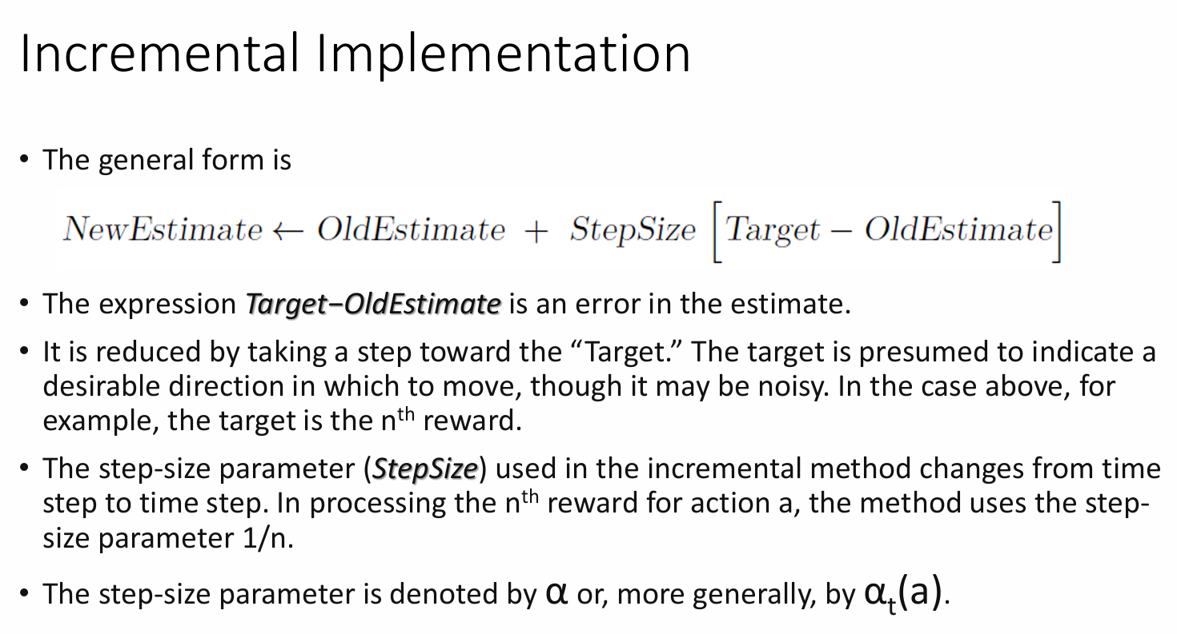

The text mentions a general form for updating estimates incrementally. This form can be applied to various contexts, not just Q-learning. Here's how it works:

* **Target - OldEstimate:** This represents the **error** in the current estimate. It's calculated by subtracting the existing estimate from the target value.
  + In Q-learning, the target is often the actual reward received (nth reward) for taking a specific action.
  + The old estimate refers to the previous Q-value associated with that action.
* **Step toward the Target:** The error is used to adjust the estimate. The update moves the estimate closer to the target by a certain amount. This amount is determined by a step-size parameter.

**Step-Size Parameter (α):**

This parameter controls the **magnitude of the adjustment** made to the estimate during each update. Here's what the text highlights about the step-size parameter in this specific incremental implementation:

* **Decreasing Step Size (1/n):** The step size used in this method is not constant. It decreases with each update (n represents the number of rewards processed for a particular action). This means the adjustments to the estimate become smaller as more data (rewards) is accumulated.
* **Benefits:**
  + A decreasing step size helps to **stabilize the learning process**. With more data, the estimates become more reliable, and smaller adjustments help to prevent overfitting to noise or random fluctuations in the rewards.
  + It ensures the influence of older rewards gradually diminishes as the agent gathers more recent information.

**Overall Significance:**

This incremental update method with a decreasing step size allows the agent to learn and refine its Q-value estimates efficiently. It leverages new information (rewards) while considering past experiences, ultimately converging towards a more accurate understanding of the best actions to take in different situations.

**Additional Notes:**

* The notation α or αt(a) for the step-size parameter is commonly used in reinforcement learning. α represents a general learning rate, while αt(a) specifies the learning rate for action 'a' at time step 't'.

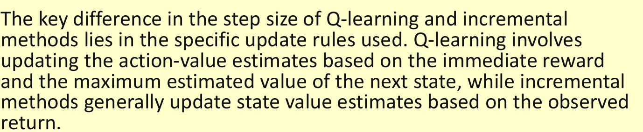

* **Update Rule:** The standard Q-learning update rule uses α to combine the following elements:
  + Previous Q-value (Q(t-1)(A)) for the chosen action (A) at time step (t-1).
  + Reward (R_t) received at the current time step (t).
  + Maximum estimated Q-value (max(Q(t-1)(A'))) among all possible actions (A') in the next state.

Here's a simplified representation of the update rule (specific forms might vary):

Q_t(A) = (1 - α) * Q_(t-1)(A) + α * (R_t + γ * max(Q_(t-1)(A')))

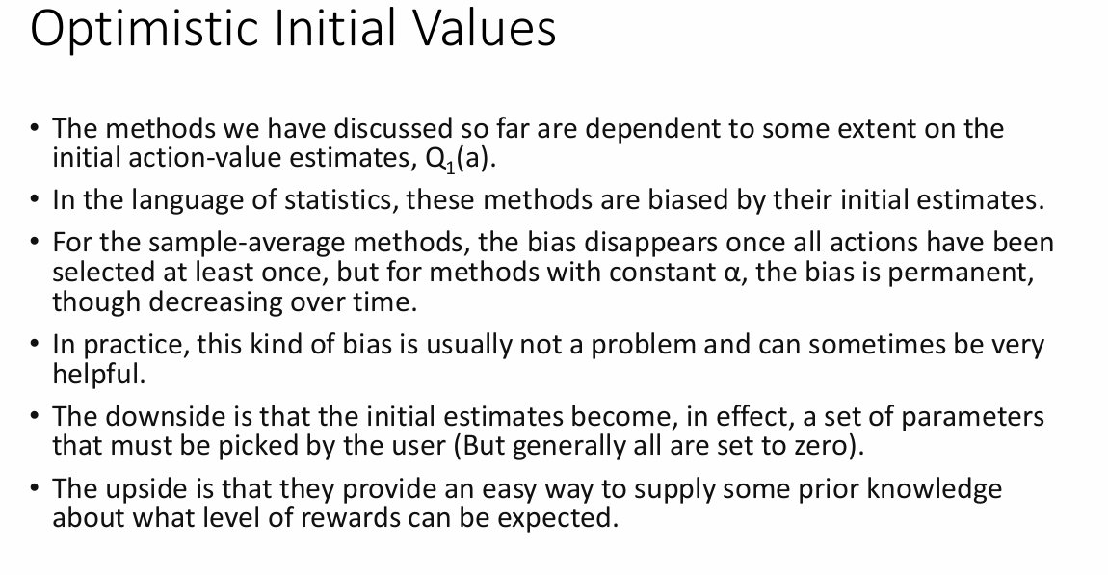

The text describes the role of initial Q-value estimates (action-value estimates) in Q-learning, a popular reinforcement learning algorithm. Here's a breakdown of the key points:

**Initial Q-Value Estimates (Q1(a))**

In Q-learning, Q-values represent the estimated **expected future reward** an agent can acquire by taking a specific action (a) in a given state. These estimates are crucial for the agent to learn an optimal policy (choosing the best actions to maximize long-term rewards).

**Impact of Initial Values**

The text highlights that the methods discussed so far depend on the initial Q-value estimates (Q1(a)). Here's how they can affect the learning process:

* **Bias:** Depending on the initial values, the estimates can be biased, meaning they might not accurately reflect the true value of each action.
  + Sample-average methods: This bias disappears once all actions have been explored at least once, as the agent gathers data and refines its estimates.
  + Constant α methods: The bias can be permanent but diminishes over time as the agent interacts with the environment and receives rewards.

**In Practice:**

* **Potential Problem:** Setting all initial Q-values to zero might not be ideal, especially if the agent has some prior knowledge about the environment or the potential rewards for certain actions.
* **Benefits of Initial Values:**
  + **Exploration:** Setting optimistic initial values (higher than expected) can encourage exploration. The agent is more likely to try different actions initially, even if they haven't been explored yet.
  + **Incorporating Prior Knowledge:** If you have some idea about the potential rewards in the environment, you can set the initial Q-values accordingly to guide the agent's learning process.

**Overall Significance:**

While initial Q-value estimates can introduce bias, they can also be a valuable tool. Carefully chosen initial values can:

* **Improve exploration:** Encourage the agent to try different actions and potentially discover better options.
* **Leverage prior knowledge:** If available, incorporate some domain knowledge about the potential rewards to steer the learning process in a more efficient direction.

It's important to consider the specific problem and available knowledge when deciding how to set the initial Q-value estimates.

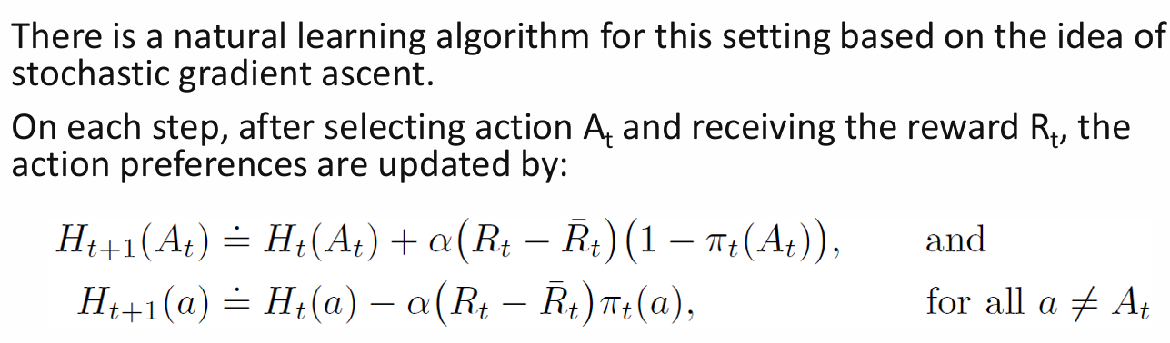

The passage describes the update rule for action preferences in a Gradient Bandit Algorithm using a concept from optimization called stochastic gradient ascent. Here's a breakdown:

**Gradient Bandit Algorithm Recap**

As discussed earlier, Gradient Bandit algorithms in multi-armed bandit problems focus on learning **preferences (Ht(a))** for each action (a) at a given time step (t). These preferences guide the agent's exploration and don't directly translate to expected rewards.

**Update Rule with Stochastic Gradient Ascent**

The passage introduces the update rule for these preferences using stochastic gradient ascent, a common optimization technique. Here's an intuitive explanation:

* **Goal:** The update aims to adjust the preferences (Ht(a)) to **favor actions that lead to higher rewards (Rt)** in the long run.
* **Stochastic Gradient Ascent:** This approach makes small adjustments in the direction that is likely to increase the preference for actions associated with higher rewards.
  + **Notation:**
    - Ht(a): Preference for action a at time step t.
    - Rt: Reward received after taking action At at time step t.
    - ηt(a): Learning rate (a small value that controls the step size of the update).

**Breakdown of the Update Rule:**

The update rule consists of two parts:

1. **Update for the Chosen Action (At):**
   * Ht+1(At): Updated preference for the chosen action (At) at the next time step (t+1).
   * Ht(At): Previous preference for the chosen action (At) at the current time step (t).
   * ηt(At): Learning rate for the chosen action (can be adapted for different actions).
   * (Rt - ¯Rt): The difference between the reward received (Rt) and a **baseline reward (¯Rt)**. This difference indicates how much better (positive difference) or worse (negative difference) the chosen action performed compared to the baseline expectation.
2. **Update for Other Actions (a ≠ At):**
   * Ht+1(a): Updated preference for action a (other than the chosen action) at the next time step (t+1).
   * Ht(a): Previous preference for action a at the current time step (t).
   * A small update term (often 0) is applied to these preferences, indicating that they are not directly influenced by the reward received in the current step since those actions weren't chosen.

**Key Points:**

* The update for the chosen action considers the difference between the actual reward and a baseline, allowing the agent to adjust its preferences based on how well the action performed compared to expectations.
* The updates for other actions are minimal, essentially keeping their preferences unchanged unless they are chosen in subsequent steps.

The passage describes the Markov Decision Process (MDP) framework, a popular approach in reinforcement learning (RL). Here's a summary of the key points:

**MDP Framework Overview:**

* MDPs model the interaction between an **agent** and its **environment**.
* The agent aims to learn a policy (strategy) to make decisions (actions) that maximize its long-term reward.

**Key Components:**

* **States (S):** Represent the different situations the agent can be in.
* **Actions (A):** Represent the choices the agent can make in each state.
* **Rewards (R):** Represent the feedback signals the agent receives for taking actions in certain states.

**Agent-Environment Boundary:**

* The MDP framework separates the agent from its environment.
* The agent can't directly control anything outside its boundary (environment).
  + This includes the agent's physical body (muscles, sensors) in biological agents or robots.
* The agent might have some knowledge about the environment (e.g., reward structure) but cannot change it arbitrarily.

**MDP Advantages:**

* **Simplified Learning:** By focusing on states, actions, and rewards, MDPs provide a manageable framework for RL problems.
* **Wide Applicability:** The MDP framework can be applied to various scenarios, from robot control to game playing, despite the underlying complexities.

**Limitations and Considerations:**

* **State Representation:** Choosing an effective way to represent states can significantly impact the agent's performance. This aspect is currently more art than science.
* **Not All Problems:** MDPs might not perfectly capture all decision-making problems, but they offer a powerful and widely applicable foundation for RL.

**In essence:**

The MDP framework provides a simplified yet powerful model for understanding and tackling reinforcement learning problems. By separating the agent from its environment and focusing on states, actions, and rewards, MDPs enable the development of learning algorithms that can help agents make optimal decisions to achieve their goals.

**Reinforcement Learning with MDPs: Key Points and Exercises**

This passage dives into the application of Markov Decision Processes (MDPs) in reinforcement learning (RL). Here's a breakdown of the key points and exercises:

**MDP Framework Recap**

* MDPs model the interaction between an agent and its environment.
* The agent aims to learn an optimal policy (strategy) by taking actions that maximize long-term rewards.
* Three key components define an MDP:
  + **States (S):** Represent different situations the agent encounters.
  + **Actions (A):** Represent choices the agent can make in each state.
  + **Rewards (R):** Represent feedback signals for taking actions in certain states.

**State and Action Representation:**

* The passage highlights the importance of choosing effective representations for states and actions. This significantly impacts the agent's learning performance.

**Examples:**

* **Bioreactor Control (Example 3.1):**
  + **States:** List of sensor readings, symbolic inputs (ingredients, target chemical).
  + **Actions:** Target temperature and stirring rate vectors.
  + **Rewards:** Rate of chemical production.
* **Robot Arm Control (Example 3.2):**
  + **States:** Joint angles and velocities.
  + **Actions:** Voltages applied to each motor at each joint.
  + **Rewards:** +1 for successful pick-and-place, small negative reward for jerky movements.

**Exercises:**

* **Exercise 3.1:** Design three MDP examples with distinct states, actions, and rewards. (You can find these examples in the provided passage).
* **Exercise 3.2:** MDP Adequacy for All Tasks:
  + **Question:** Can MDPs represent all goal-directed learning tasks effectively?
  + **Consideration:** Think of scenarios where MDPs might not be ideal.
* **Exercise 3.3:** Agent-Environment Boundary in Driving:
  + **Scenario:** Defining actions in car driving using MDPs.
  + **Options:**
    - **Body-Machine:** Actions as physical controls (accelerator, brake, steering).
    - **Machine-Environment:** Actions as tire torques affecting the car's movement.
    - **Brain-Body:** Actions as muscle twitches controlling limbs.
    - **High Level:** Actions as destination choices.
  + **Question:** What's the "right" level for the agent-environment boundary?
  + **Considerations:** Explore the basis for choosing a specific boundary and if there's a fundamental reason for preference.

**In essence:**

MDPs provide a valuable framework for RL by decomposing decision-making problems into states, actions, and rewards. However, it's crucial to carefully represent these elements for effective learning. The exercises encourage you to explore the flexibility and limitations of MDPs in various scenarios.

The Markov Property is a concept used in probability theory and statistics. It describes a system with a kind of "memorylessness." Here's a breakdown of the key points:

**Memoryless System:**

A system is said to satisfy the Markov Property if the future behavior of the system depends only on its current state and not on its entire history of past states. In simpler terms, the past doesn't directly influence the future, only the present state matters.

**Understanding the Property in Context:**

* **Stochastic Processes:** The Markov Property is often applied to stochastic processes, which are sequences of random events. These processes can model various real-world phenomena, such as weather patterns, stock prices, or game states.
* **State and Future Probability:** In a Markov process with the Markov Property, the probability of transitioning to a future state depends solely on the current state, not on the sequence of states that led to it.

**Example:**

Imagine a simple weather model with two states: sunny and rainy. If today is sunny, the probability of rain tomorrow only depends on the current weather (sunny) and not on whether it rained yesterday or the day before. This system exhibits the Markov Property.

**Benefits of Markov Property:**

* **Simpler Modeling:** Processes with the Markov Property are often easier to analyze and model mathematically because we only need to consider the current state, not the entire history.
* **Applications in Various Fields:** The Markov Property has applications in many areas, including signal processing, information theory, queueing theory, and reinforcement learning.

**Important Note:**

While the Markov Property implies a kind of memorylessness, it doesn't necessarily mean the past is entirely irrelevant. The current state itself might be a result of past events, but the influence of the past is captured indirectly through the current state.

## Describe the application of RL to the real world problem of Job Shop Scheduling

**Reinforcement Learning for Job Shop Scheduling**

Job shop scheduling is a common challenge in manufacturing and other industries where multiple jobs need to be completed on a limited number of machines. The goal is to find an optimal schedule that minimizes factors like completion time, makespan (total time to finish all jobs), or idle time for machines. Here's how reinforcement learning (RL) can be applied to this real-world problem:

**Challenges of Traditional Methods:**

* **Complexities:** Traditional scheduling algorithms can struggle with highly complex scenarios with many jobs, machines, and dependencies.
* **Static Environments:** Most algorithms assume a static environment where job properties and machine availability remain constant, which isn't always true in real-world situations.

**Advantages of RL:**

* **Dynamic Environments:** RL excels in dynamic environments. The agent can learn and adapt to changes in job arrivals, machine breakdowns, or priority updates.
* **Flexibility:** RL algorithms can be trained on historical data or simulations, allowing them to learn effective scheduling strategies specific to the job shop's unique constraints.
* **Optimization:** RL can continuously learn and improve its scheduling decisions over time, potentially leading to better solutions compared to static rules.

**How RL Works in Job Shop Scheduling:**

1. **Environment:** The job shop environment is simulated, including machines, jobs with processing times, and potential disruptions.
2. **Agent:** An RL agent observes the current state (e.g., job queue, machine availability) and takes actions (e.g., assigning a job to a machine).
3. **Reward Function:** The agent receives a reward based on the outcome of its action (e.g., reduced makespan, minimized idle time).
4. **Learning:** The agent learns through trial and error, adjusting its scheduling decisions based on the rewards it receives. Over time, it learns to prioritize jobs and assign them to machines in a way that optimizes the desired objective.

**Challenges of RL in Job Shop Scheduling:**

* **Large State Space:** The number of possible states in a job shop can be enormous, making it computationally expensive for the agent to learn.
* **Exploration vs. Exploitation:** The agent needs to balance exploring new scheduling strategies (exploration) with exploiting already learned effective ones (exploitation).
* **Real-World Implementation:** Transferring the learned scheduling policy from a simulated environment to a real job shop with potential uncertainties requires careful considerations.

**Overall, RL offers a promising approach to job shop scheduling, particularly for complex and dynamic environments. However, addressing the challenges of large state spaces and real-world implementation remains crucial for successful application.**

## Reinforcement learning (RL) can be applied to the real-world problem of job shop scheduling to optimize the allocation of resources and minimize makespan (the total time taken to complete all jobs). Here's how RL can be applied to this problem:

## 1. **State Representation**: The first step is to define the state space. In job shop scheduling, the state can represent the current configuration of jobs, machines, and their respective statuses (idle, processing, etc.). This could be represented as a set of queues or a matrix where each entry represents the status of a machine at a particular time.

## 2. **Action Selection**: RL algorithms need to decide what action to take based on the current state. In job shop scheduling, actions could include assigning a job to a machine or moving a job from one machine to another. The set of feasible actions depends on the current state and constraints of the problem.

## 3. **Reward Design**: The reward function is crucial in RL as it determines the objective of the learning agent. In job shop scheduling, the reward could be defined as a function of makespan, tardiness, or other performance metrics. For example, the agent receives a negative reward proportional to the increase in makespan or tardiness whenever an action is taken.

## 4. **Learning Algorithm**: Various RL algorithms can be applied to job shop scheduling, including Q-learning, Deep Q-Networks (DQN), Deep Deterministic Policy Gradient (DDPG), or Proximal Policy Optimization (PPO). These algorithms learn from experience by interacting with the environment, observing rewards, and updating their policies accordingly.

## 5. **Exploration vs. Exploitation**: Balancing exploration (trying new actions to discover better policies) and exploitation (leveraging learned policies to maximize rewards) is crucial in RL. In job shop scheduling, the agent needs to explore different job-machine assignments while also exploiting known good policies to minimize makespan.

## 6. **Simulation or Real-world Implementation**: RL algorithms can be trained and evaluated in simulation environments before deploying them to real-world job shop scheduling systems. Simulation allows for rapid experimentation and testing of different algorithms and parameters without disrupting actual production processes. Once validated, RL policies can be deployed in real-world scenarios, potentially with further fine-tuning.

## Overall, RL provides a flexible framework for addressing the complex and dynamic nature of job shop scheduling problems, enabling the discovery of optimized scheduling policies that can adapt to changing conditions and constraints.

## Describe the application of RL to the real world problem of Elevator Dispatching

Reinforcement learning (RL) offers a promising approach to address the real-world problem of elevator dispatching, which involves efficiently controlling the movement of elevators to transport passengers between different floors of a building. Here's how RL can be applied to this problem:

1. **State Representation**: The state in elevator dispatching can be represented by various factors such as the current floor of each elevator, the direction it is moving, the number of passengers waiting on each floor, the destination floors of waiting passengers, and the time elapsed since the last elevator action. This information provides a comprehensive snapshot of the system's status, enabling the RL agent to make informed decisions.
2. **Action Selection**: The actions available to the RL agent correspond to the control inputs for each elevator, such as moving up, moving down, stopping, opening doors, and closing doors. The agent needs to decide which action to take for each elevator based on the current state and the overall goal of minimizing passenger waiting times and energy consumption.
3. **Reward Design**: The reward function is designed to encourage behaviors that lead to improved performance in elevator dispatching. Rewards can be based on various factors, including minimizing passenger waiting times, maximizing the number of passengers served per unit time, minimizing energy consumption, and optimizing elevator utilization. For example, the agent may receive a positive reward for efficiently transporting passengers and a negative reward for excessive energy consumption or long waiting times.
4. **Learning Algorithm**: RL algorithms such as Q-learning, Deep Q-Networks (DQN), Deep Deterministic Policy Gradient (DDPG), or Proximal Policy Optimization (PPO) can be applied to learn effective elevator dispatching policies. These algorithms learn from experience by interacting with the environment, observing rewards, and updating their policies to maximize long-term cumulative rewards.
5. **Exploration vs. Exploitation**: Balancing exploration and exploitation is essential for discovering effective elevator dispatching strategies. The RL agent needs to explore different actions to learn about the dynamics of the environment while also exploiting learned policies to optimize elevator operations in real-time.
6. **Simulation and Real-world Deployment**: RL algorithms can be initially trained and evaluated in simulated environments that accurately model the dynamics of elevator systems. Simulation allows for rapid experimentation and testing of different algorithms and parameter settings without the risk of disrupting real-world operations. Once validated, RL policies can be deployed to real-world elevator systems, potentially with further fine-tuning and adaptation to specific building layouts and usage patterns.

By applying RL to elevator dispatching, it's possible to develop intelligent control strategies that can adapt to changing passenger demand, traffic patterns, and operational constraints, ultimately leading to more efficient and responsive elevator systems.

Top of Form

Describe the application of RL to the real world problem of Dynamic Channel Allocation

Dynamic Channel Allocation (DCA) is a critical issue in wireless communication systems, particularly in cellular networks, where efficient utilization of available spectrum is essential for optimizing performance. Reinforcement learning (RL) offers a promising approach to address the challenges of DCA. Here's how RL can be applied to this real-world problem:

1. **State Representation**: In DCA, the state can be represented by various factors such as the current traffic load on different channels, the interference levels experienced by each channel, the quality of the communication links, and the historical usage patterns. This information provides a comprehensive view of the network's status, enabling the RL agent to make informed decisions.
2. **Action Selection**: The actions available to the RL agent correspond to the allocation of channels to different users or communication links. The agent needs to decide which channels to assign to which users based on the current state and the overall goal of maximizing throughput, minimizing interference, and ensuring fair allocation of resources.
3. **Reward Design**: The reward function is designed to encourage behaviors that lead to improved performance in DCA. Rewards can be based on various factors, including maximizing system throughput, minimizing packet loss rates, minimizing latency, and maximizing the fairness of resource allocation among users. For example, the agent may receive a positive reward for successfully transmitting data packets without interference and a negative reward for collisions or excessive packet loss.
4. **Learning Algorithm**: RL algorithms such as Q-learning, Deep Q-Networks (DQN), Deep Deterministic Policy Gradient (DDPG), or Proximal Policy Optimization (PPO) can be applied to learn effective DCA policies. These algorithms learn from experience by interacting with the environment, observing rewards, and updating their policies to maximize long-term cumulative rewards.
5. **Exploration vs. Exploitation**: Balancing exploration and exploitation is crucial for discovering effective DCA strategies. The RL agent needs to explore different channel allocations to learn about the dynamics of the environment while also exploiting learned policies to optimize spectrum utilization in real-time.
6. **Simulation and Real-world Deployment**: RL algorithms can be initially trained and evaluated in simulated environments that accurately model the dynamics of wireless communication systems. Simulation allows for rapid experimentation and testing of different algorithms and parameter settings without the risk of disrupting real-world operations. Once validated, RL policies can be deployed to real-world communication systems, potentially with further fine-tuning and adaptation to specific network conditions and traffic patterns.

By applying RL to dynamic channel allocation, it's possible to develop intelligent resource management strategies that can adapt to changing network conditions, traffic loads, and interference levels, ultimately leading to more efficient and robust wireless communication systems.

Top of Form